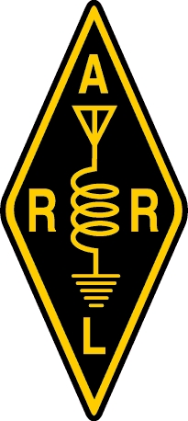**Oregon Section**

To whom it may concern,

The Oregon Section of the ARRL would like to express our support and endorsement of the OreSat0 amateur satellite being developed by the volunteer members of our section at Portland State University. This satellite offers the following benefits to the local and international amateur radio communities:

It utilizes current amateur communications modes for receiving telemetry including CW and G3RUH/AX.25/APRS.

It promotes new radio technologies including the use of underutilized L-band for space vehicle uplink, the use of higher bit rate modulation for engineering data paths, and the use of 802.11b as an amateur radio protocol.

Finally, the satellite has a strong educational component; all of the satellite hardware, firmware, and software are publicly available and licensed as open source and available for other amateur radio satellite builders and users.

Please contact me if you have any concerns or questions.

Sincerely,

David Kidd

ARRL Oregon Section Manager

ka7ozo@arrl.org

503-320-3484 Cell